Software Requirements Specification

Version 1.0

02/09/2009

SmartCMS

Your Web Design Made Easy

by

John Allen
Johnathan Hasty
Matthew June
Norman McGarry
Kenneth Musthaler

HISTORY OF CHANGE
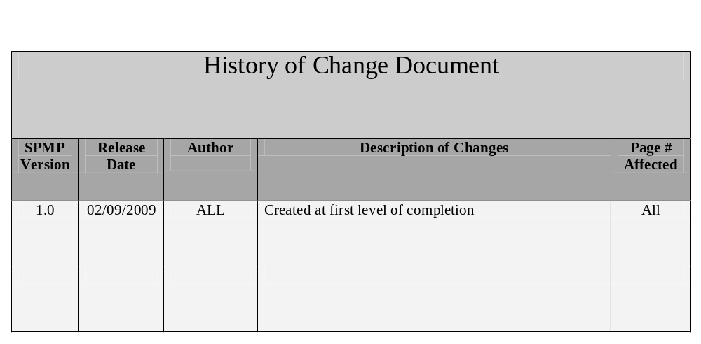

PREFACE

This Software Requirements Sheet is compliant with the IEEE Standard for Software Requirements Specification

The Software Requirements Sheet for Smart CMS outlines the Scope and the managerial aspects of the project, including a specific requirments, descriptions of operations and possible contsraints. A class list along with CRC cards are also included in this plan. The main goal of the Smart CMS is to create an easy to use system that will allow people without any knowledge of Hypertext Markup Language (HTML) programming to modify their websites. The target audience for this document includes; project team members, project sponsors and project stakeholders such as small to medium businesses that currently have their own Websites.

Software Requirements Specification
SmartCMS 1
HISTORY OF CHANGE 2
PREFACE 3
TABLE OF CONTENTS 4
LIST OF FIGURES 5
1. Introduction 6
1.1 Purpose 6
1.2 Scope 6
1.3 Definitions, acronyms, and abbreviations 6
1.4 References 7
1.5 Overview 7
2. Overall Description 7
2.1 Product Perspective. 8
2.2 System Interface. 9
2.3 Product Functions 9
2.4 User Characteristics. 11
2.5 Operating Environment. 11
2.6 Consrataints. 11
2.7 Assumptions and Dependencies. 11
2.8 Appointing of Requirements. 12
3 External Interface Requirements 12
User Interfaces 12
Hardware Interfaces 12
Software Interfaces 12
4 Speciific Requirements 13
4.1 Analysis Diagrams. 8
Top Level Use Case Diagrams 26
Use Case Diagrams 28
CRC Cards 26
Class List 28
Sequence Diagrams 28
Class Diagram, Parser Controller 26
Class Diagram, Template Parser 28

List of Figures
Figure | Page
Figure 1: History of Changes Document | History of Changes page
Figure 2: Definitions and Acronyms | 6
Figure 3: Hatley Pirbhai Model | 8
Figure 4: System Interface Model | 9
Figure 5: Context Diagram | 10
Figure 6: Top Level Use Case Diagram | 13
Figure 7: Use Case Diagrams | 14
Figure 8: CRC Diagrams | 19
Figure 9: Class List | 27
Figure 10: Sequence Diagrams | 29
Figure 11: Class Diagram, Parser Controller | 36
Figure 12: Class Diagram, Template Parser | 37

1. Introduction
1.1 Purpose
See PREFACE.
1.2 Scope
It is costly for small businesses to hire web programmers to keep their websites updated. An application should be created to assist small businesses with editing and designing their webpage without this cost and without them needing to learn html.
SmartCMS is a new application developed to create an easy to use system that will allow people without any knowledge of html programming to modify their websites.
Problem statement:
It is costly for small businesses to hire web programmers to keep their websites updated. An application should be created to assist small businesses with editing and designing their webpage without this cost and without them needing to learn html.
Project goals and objectives:
The goal of the Smart CMS is to create an easy to use system that will allow people without any knowledge of html programming to modify their websites.
What program is this code written in?
PHP 5.0 with a MySQL 5.0 database or ASP.NET C# with a MSSQL database. Pros and cons need to be weighed.
List of Needs
Basic Apache server hosting environment or a machine that we can setup apache on with PHP and MySQL enabled, or a Windows Server for development using ASP.NET and MSSQL.
Project Non-Goals:
The prototype version of Smart CMS will not:
- Create templates for the user.
- Submitted changes are not reversible.
- Not consistent with error or grammar checking/correction.

1.3 Definitions, acronyms, and abbreviations
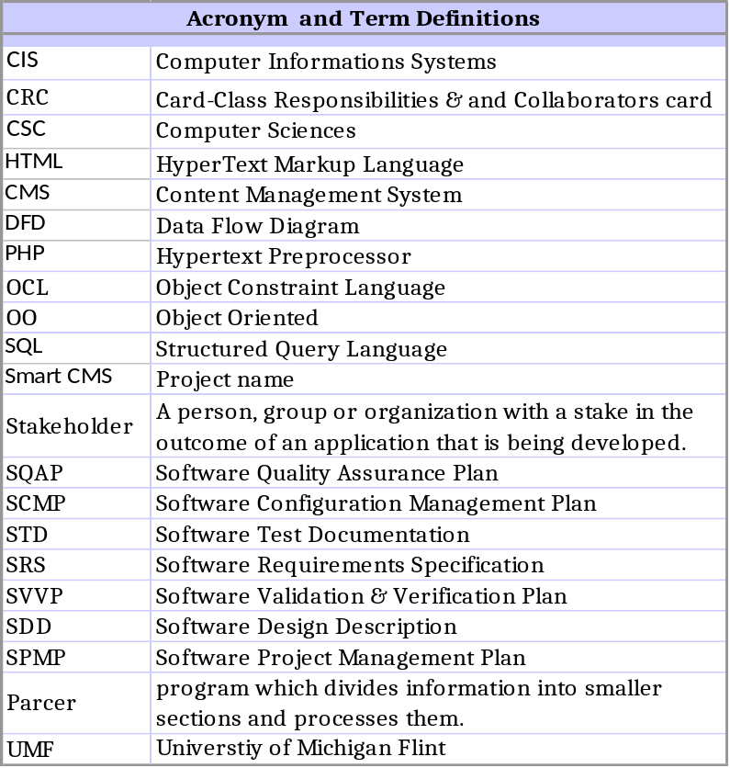

1.4 References
This subsection should:
- Roger S. Pressman, Software Engineering: A Practitioner’s Approach, 6/e, McGraw Hill, 2005.
- Blackboard, requirements_spec.pdf, IEEE Software Requirements Specification.

1.5 Overview
The rest of this SRS document contains the overall description of the product, SmartCMS. This includes but is not limited to: Product perspective and functions, user characteristics, constraints, assumptions, and dependencies.
This SRS is organized by following the formatting specified by IEEE standards for developing a Software Requirements Specification.

2. Overall Description

2.1 Product Perspective
It is costly for small businesses to hire web programmers to keep their websites updated. An application should be created to assist small businesses with editing and designing their webpage without this cost and without them needing to learn html. This software is similar to Dreamweaver but with much easier capabilities. The Smart CMS will much easier and friendlier than any other leading software.
SMART CMS SYSTEM HATLEY PIRBHAI MODEL
SMART CMS
User Interface Processing
Log In Screen
Create a Page
Upload New
Template
Manage User
Accounts
OUTPUT PROCESSING
INPUT PROCESSING
Edit a Page
Webpage Viewer
Pages Area
View a Page
Super User
Admin User
MySQL
Login Interface
Template
Maintenance and Test
Parser
2.2 System Interface
As Smart CMS application user interfaces with this software loaded on his desktop, the application will interface via LAN connection with MySQL and remote or locally stored web pages, via the Internet. HTTP requests access, create and edit templates in MySQL Template database via the Controller, Actor, Business, and Information Holder classes of the Smart CMS application. With all this functionality seamless to the user, the end results are the easily edited or created web pages.
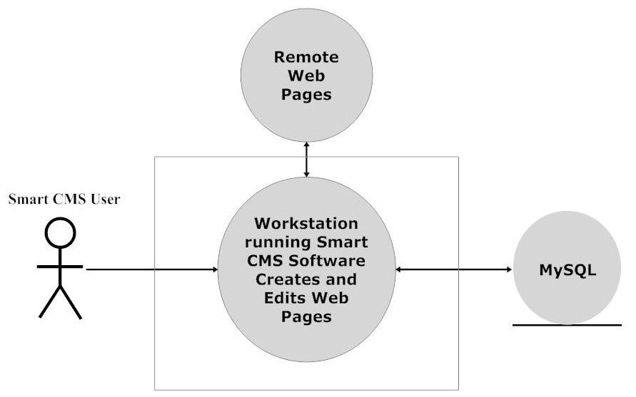
Figure System Interface

2.3 Product Functions
The Smart CMS will have a secure login. Multiple user levels will control what the users are able to do. The user will have options to load or create templates, edit or add pages, view or submit the finished product. The Smart CMS will have error proofing for any problem that occurs, for example when creating a new login or creating a new page.
Smart CMS Software Context Diagram
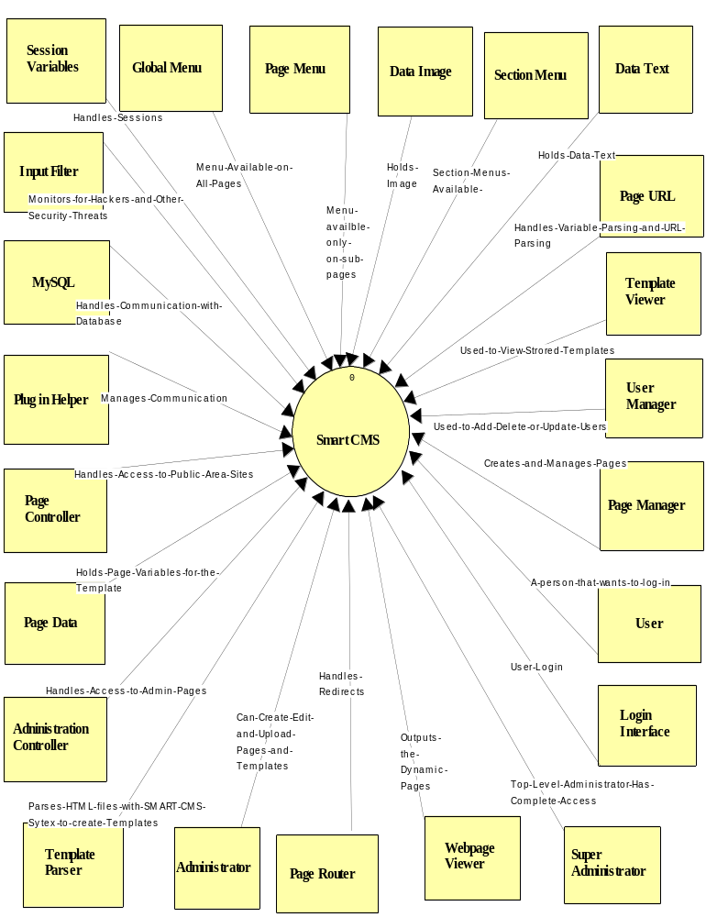

2.4 User Characteristics
Typical users for Smart CMS are going to be mainly the owners of the websites and any computer administrators a company may already have. The Smart CMS is very user friendly and will work for even the most computer illiterate people around. Overtime Smart CMS will allow companies to reduce staff and have just one or two people controlling their entire website.

2.5 Operating Environment
As the system is uniquely and solely designed for the purposes outlined here, the operation environment is predetermined and explicitly chosen for its qualities that are ideal to the purpose of the system. This system is independent of any other hardware or software and requires no additional specifications. Any modification to the system is not supported by this SRS and should be accompanied by its own documentation.

2.6 Constraints
Constraints are to be determined based on pending hardware design. As this system is entirely new, many changes will occur to both the software and hardware subsystems during the design process. Complete constraint specifications are dependent on subsequent prototypes, some examples may include:
- Hardware or software environment
- End-user environment
- Availability or volatility of resources
- Standards compliance
- Interoperability requirements
- Interface/protocol requirements
- Data repository and distribution requirements
- Security requirements
- Memory and other capacity limitations
- Performance requirements
- Network communications
- Verification and validation requirements

2.7 Assumptions and Dependencies
This software will be unique to its nature as far as its simplistic operation. Smart CMS will be capable of running on all working OS such as Windows, MAC, PC and UNIX.
2.8 Appointing of Requirements
Currently there are no delayed requirements planned for future releases of the SmartCMS system.

3 External Interface Requirements
3.1 User Interfaces
Design and implantation constraints are to be determined based on pending hardware design. As this system is entirely new, many changes will occur to both the software and hardware subsystems during the fluid design process. Complete constraint specifications are dependent on subsequent prototypes, as they are available.

3.2 Hardware Interfaces
When the user logs in the system processes the users request and redirects the user to the admin homepage and stores all information into memory. When the user uploads a new template the system accesses memory and retrieves the template needed. When the user requests a new page to be loaded the system hardware the system finds the new page template inside the hard drive and loads it for the user. All steps involved in running the Smart CMS use the systems hardware to locate, retrieve and save user information.

3.3 Software Interfaces
The software will allow the user to interact with the website and make changes as needed. It will allow the user to update the database by adding new pages, create new templates, and edit current information by using the Smart CMS system.
4 Specific Requirements

4.1 Analysis Diagrams:
Top Level Use Case Diagram:
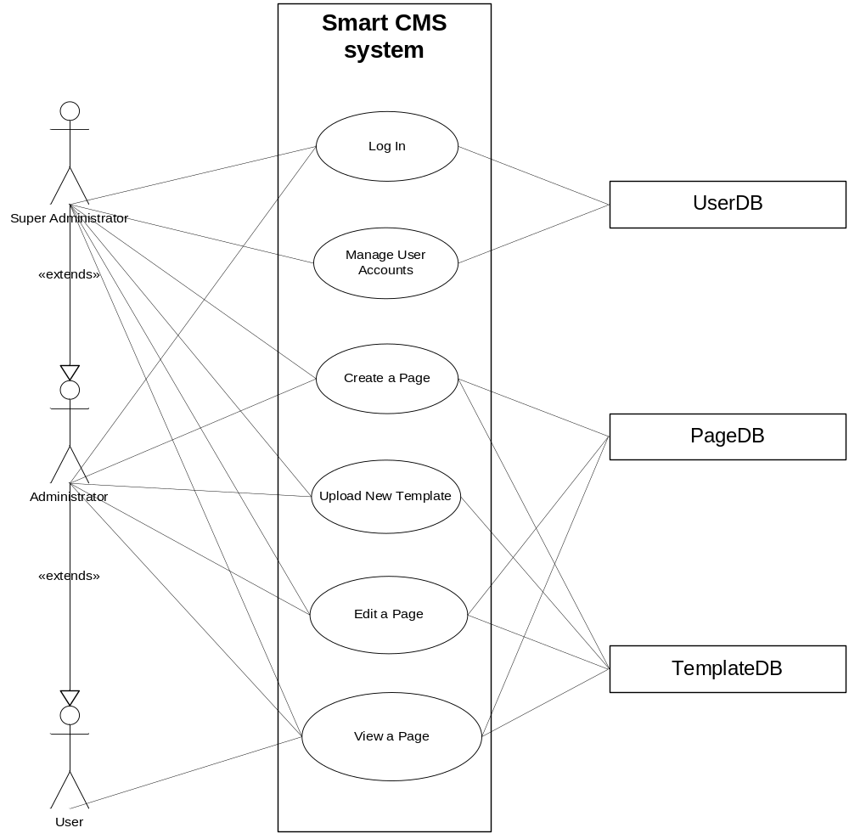
Use Case Diagrams:
Use Case Name: Logging on with correct credentials
Primary Actor: SmartCMS user-not logged in
Secondary Actor: User database

Description of Usage:
- Actor types the URL to the admin area of the site.
- System returns the login page with a request for a actor name and password.
- The actor inputs his/her actor name and password.
- The system redirects the actor to the admin homepage.

Use Case Name: Logging on with incorrect credentials
Primary Actor: SmartCMS user-not logged in
Secondary Actor: User database

Description of Usage:
- Actor types the URL of the admin area of the site.
- System returns the login page with a request for an actor name and password.
- The actor inputs his/her actor name and password.

  - The system responds with a message telling the actor that their actor name and password is incorrect.
  - The system responds with a prompt for the actor name to recover his/her password via email.
- The actor can retry or get his/her credentials emailed to them.

Class-Responsibility-Collaborator Modeling (CRC CARDS):
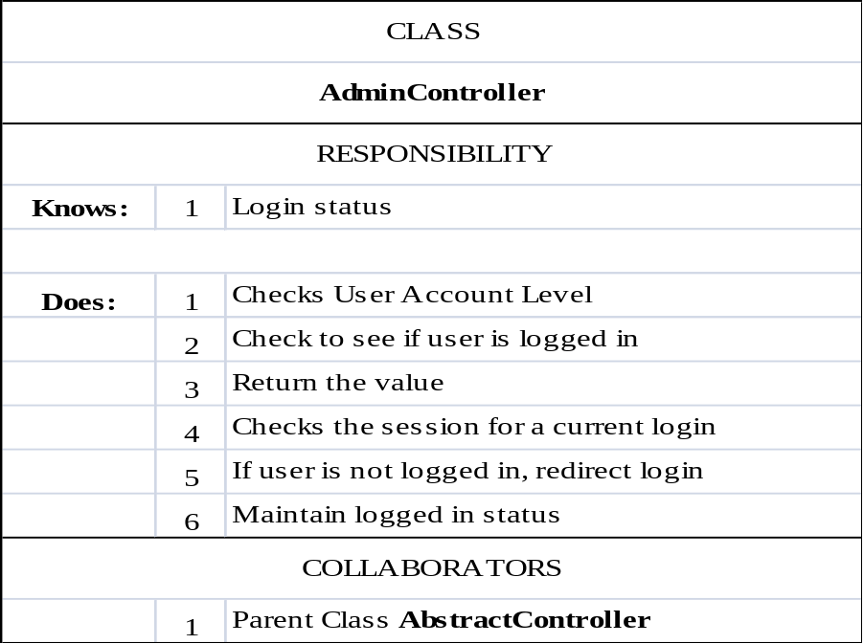
Use Case Name: Upload a new template with no errors
Primary Actor: SmartCMS user-logged in
Secondary Actor: The database

Description of Usage:
    - The actor is logged into the system and the actor clicks the Upload Template link in the menu.
    - The system returns a page with an upload form.

  - The actor clicks the browse button on the form and selects the template file.
  - The actor clicks the submit button.

  - The system handles the upload and verifies correct file type and file size.
  - The system parses the file for template syntax to build the data structure representing the page. The system returns a page contain an outline of how it interpreted the template.
  - The system prompts the actor to approve the outline.
- The actor accepts the template

Use Case Name: Upload a new template with errors
Primary Actor: SmartCMS user-logged in
Secondary Actor: The database

Description of Usage:
    - The actor is logged into the system and the actor clicks the Upload Template link in the menu.
    - The system returns a page with an upload form.

  - The actor clicks the browse button on the form and selects the template file.
  - The actor clicks the submit button.

  - The system handles the upload and verifies correct file type and file size.
  - The system parses the file for template syntax to build the data structure representing the page. The system returns a page contain an outline of how it interpreted the template.
  - The system prompts the actor to approve the outline.

  - The actor denies the template because he/she found error.
- The system returns the actor to the upload form.

Use Case Name: Create a page
Primary Actor: SmartCMS user-logged in
Secondary Actor: The database

Description of Usage:
- The actor is logged in and clicks the Create a Page link in the main menu.
- The system returns a page prompting for the following data: which template to use (drop-down box), the URL key to the page (ex. /about_us/index.html), and the page name.
- The actor fills out the data and chooses a URL Key that is not already in use or a physical does not actually exist representing the key.

  - The system checks the data and creates the page in the database.
  - The system redirects the actor to a page with a form representing all the template data.
- The actor enters the data in the form and clicks submit.
- The system validates the data and inserts it into the database. The page is now created.

Use Case Name: Edit a page
Primary Actor: SmartCMS user-logged in
Secondary Actor: The database

Description of Usage:
- The actor is logged in and clicks the View Pages link in the main menu.
- The system returns a page listing all pages created and organized by if they are a sub page of another page, or by template.
- The actor clicks on the “Edit Page” text next to the page he/she wants to edit.
- The system brings up the form representing all the template data for that page with the forms already filled out with any already existing data.

  - The actor can edit the data in the form.
  - The actor clicks submit when finished.
- The system validates the data and updates the correlating entries in the database.

Use Case Name: Add a User
Primary Actor: SmartCMS user-logged in
Secondary Actor: The database

Description of Usage:
- The actor is logged in and clicks the Add A User link in the main menu.
- The system returns a page with a form prompting the actor for data about the new user.

  - The actor fills in the data, including: email, password, checkbox to email the password, random password generation button
  - The actor submits the form.

  - The system processes the data and inserts it into the database.
  - The system emails the user their password if that option was selected.
  - The system redirects the actor to the user homepage.

Use Case Name: Viewing a page
Primary Actor: SmartCMS User-logged in
Secondary Actor: The database

Description of Usage:
- The actor types in the url in the address or clicks on a url from a search engine or link.

  - The system redirects all functionality to one core engine file.
  - The system uses the request URI and looks it up in the database.
  - The system finds the specified URI and retrieves the template and page id associated with that URI.
  - The system retrieves the template data based on the specified page id.
  - The system populates the template using the template data retrieved.
  - The system returns the page.
- The actor views the page.

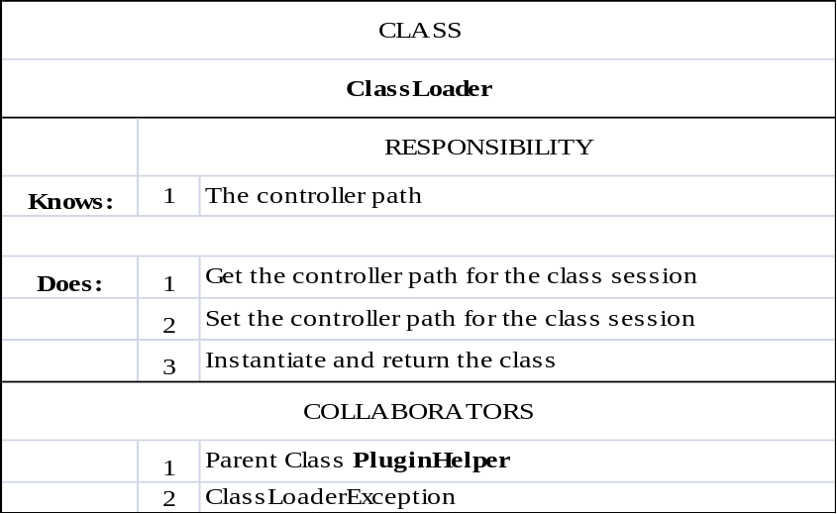
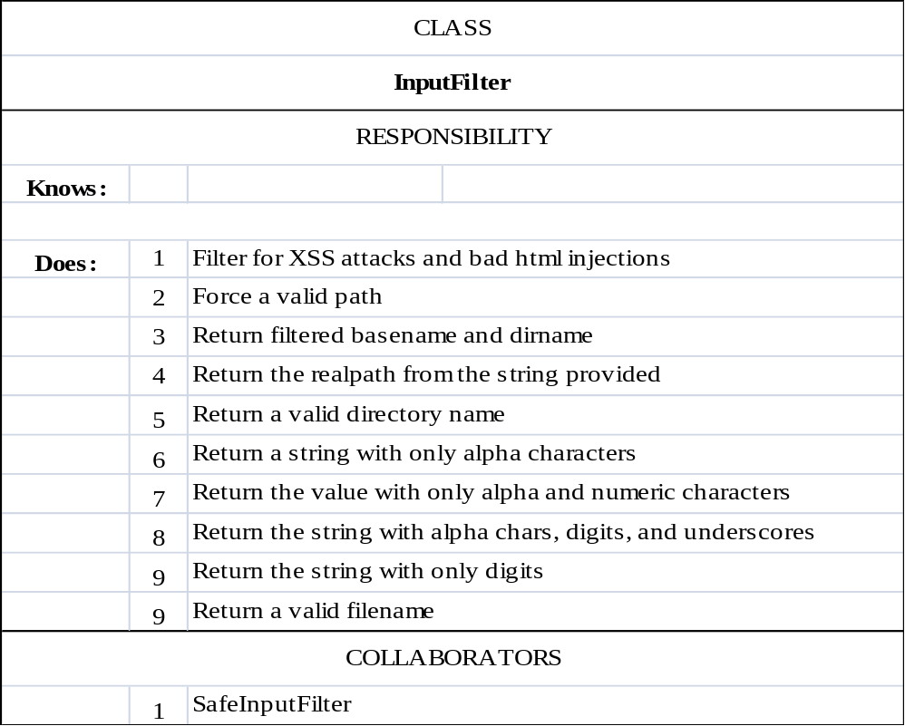
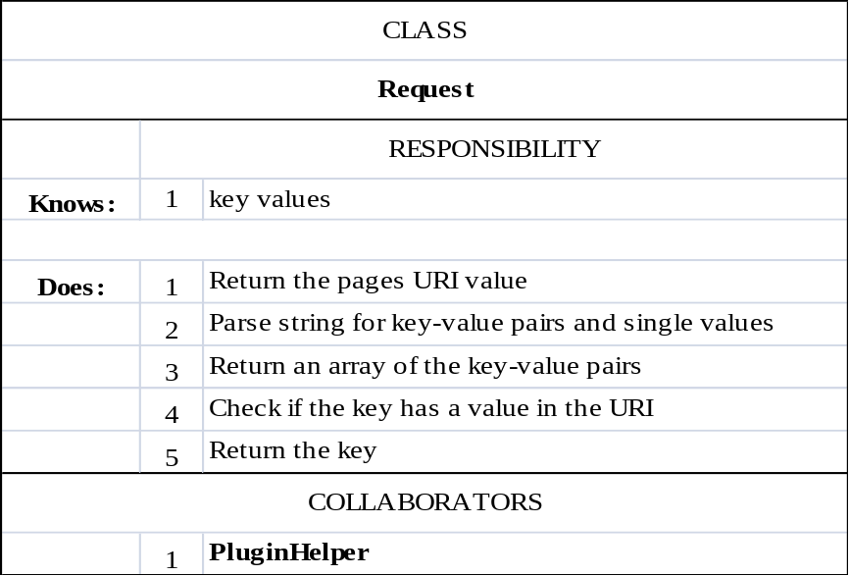
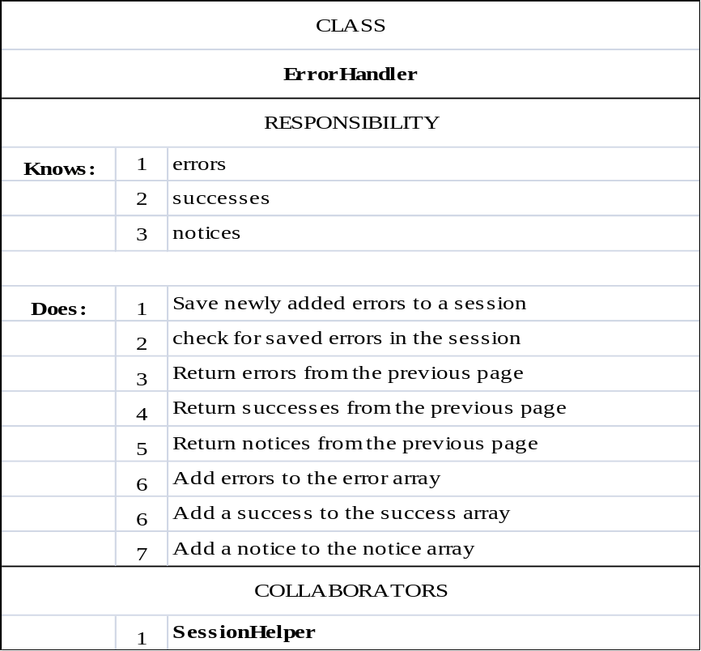
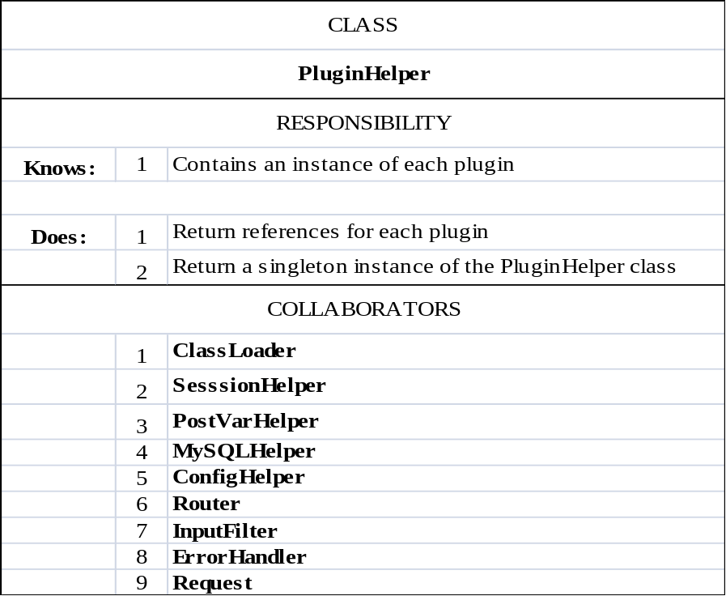

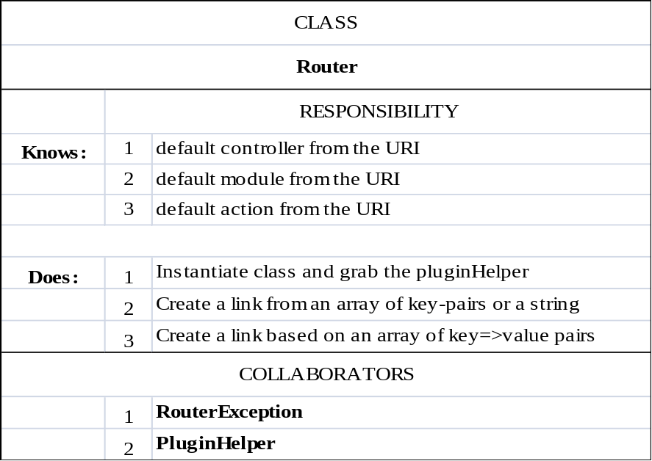

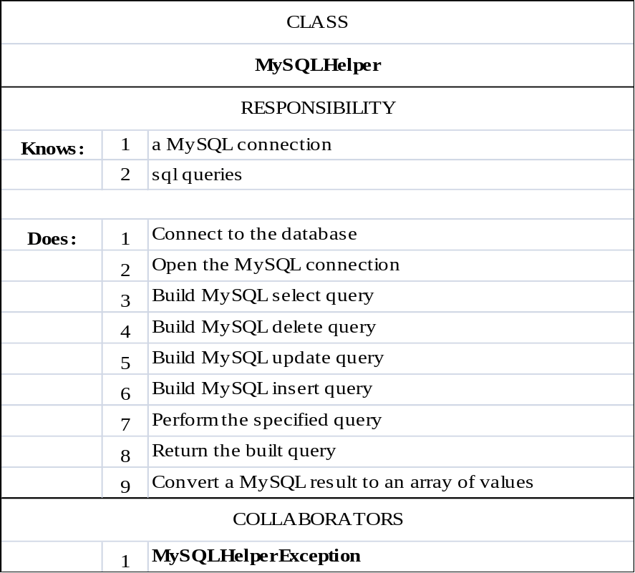

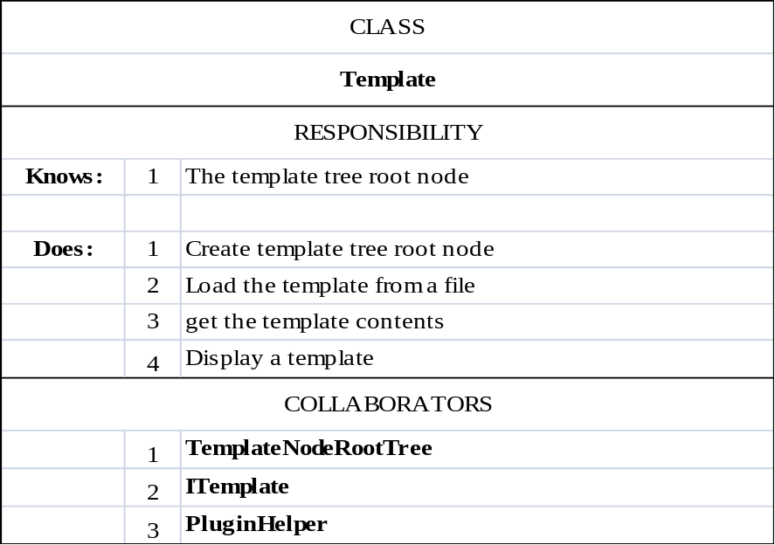
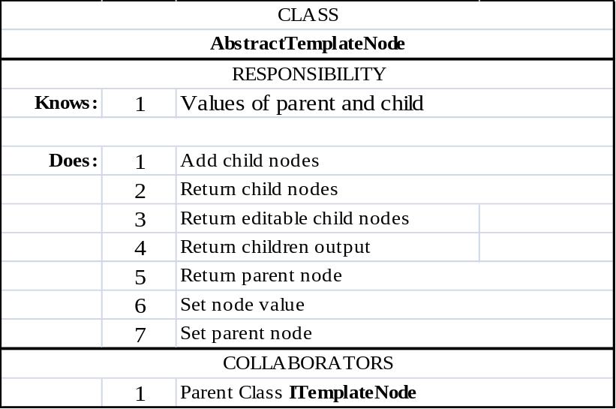
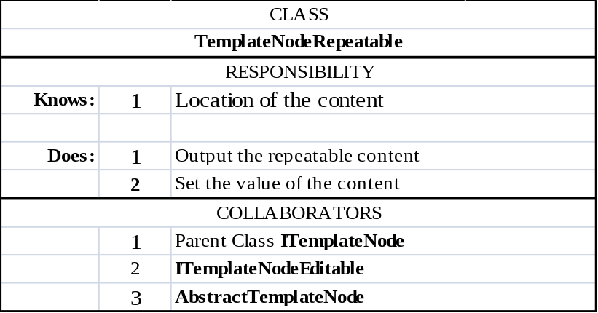
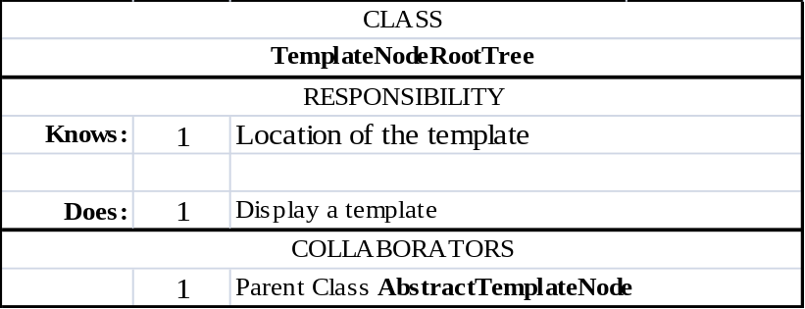
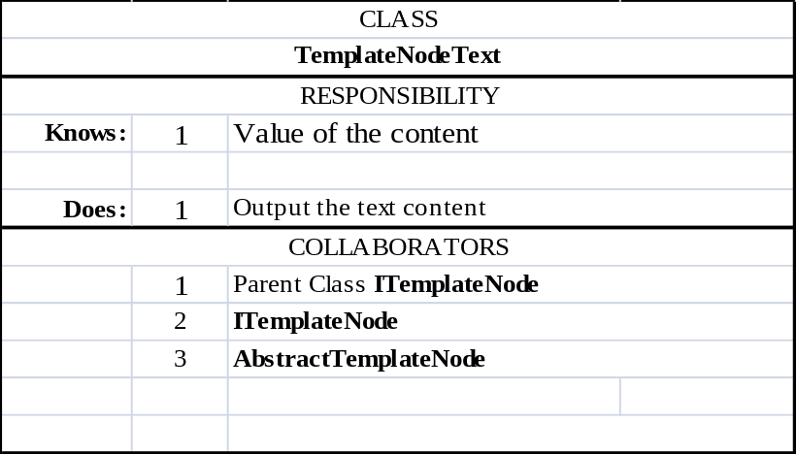
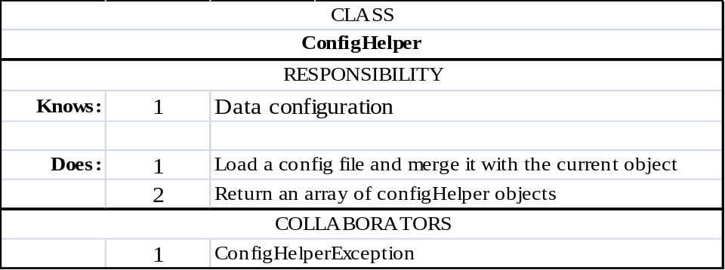
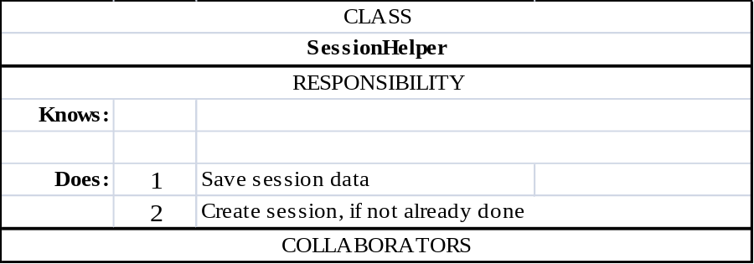
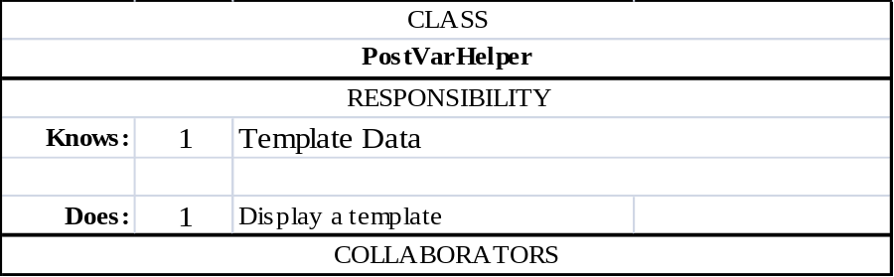
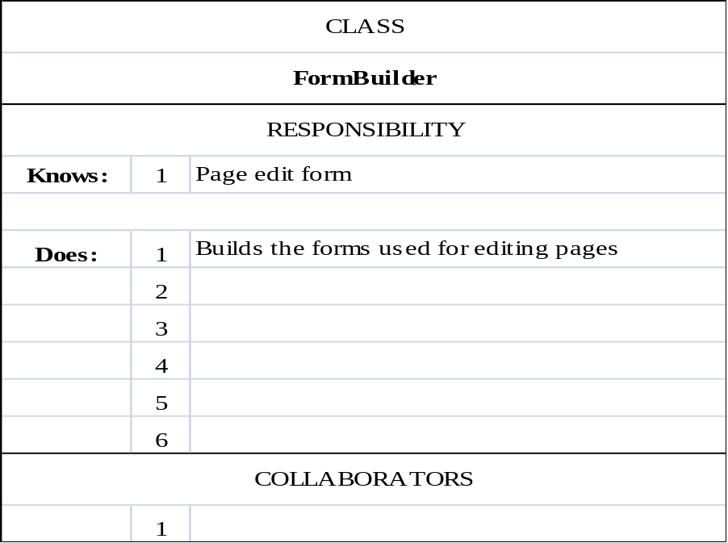
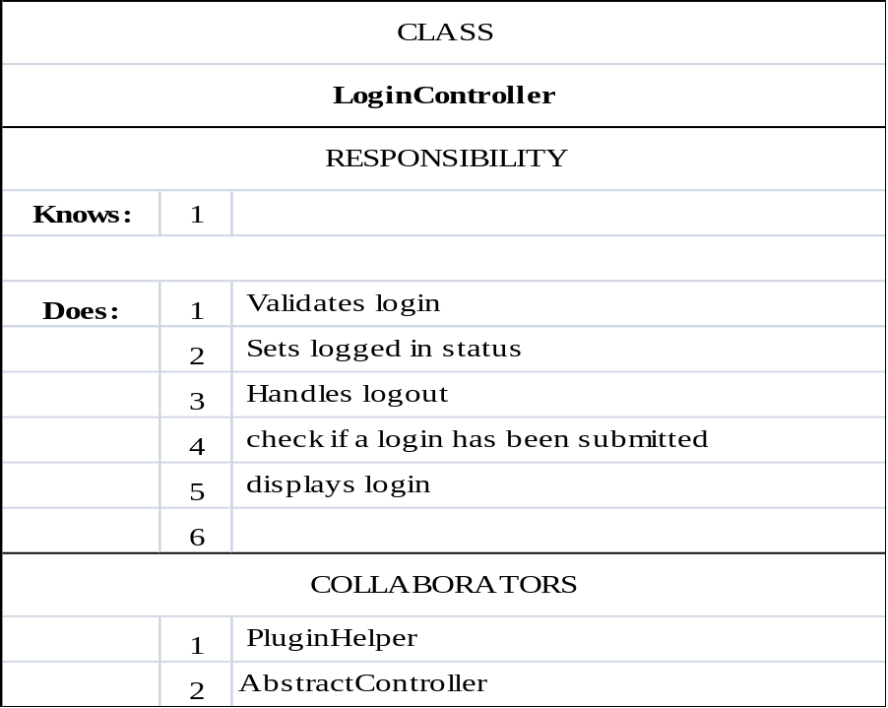
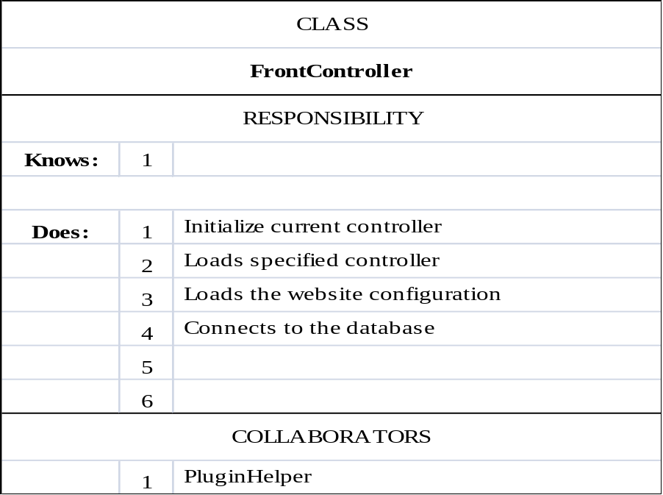
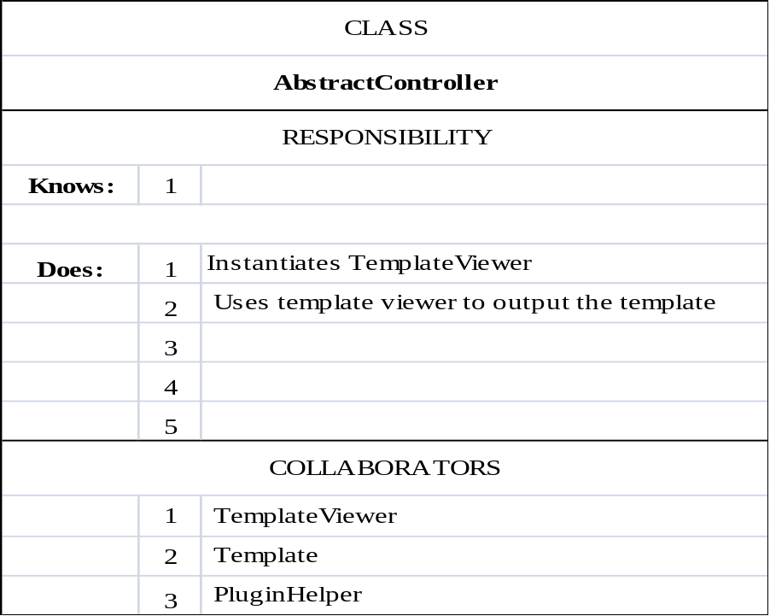
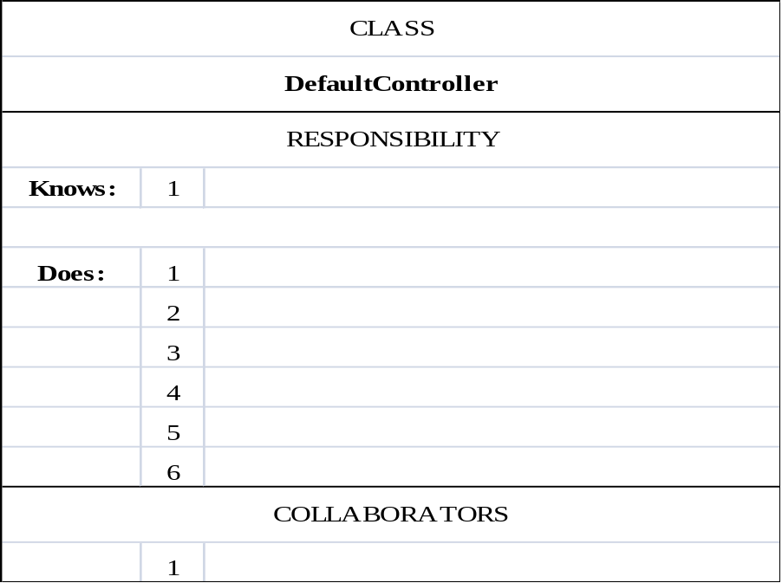
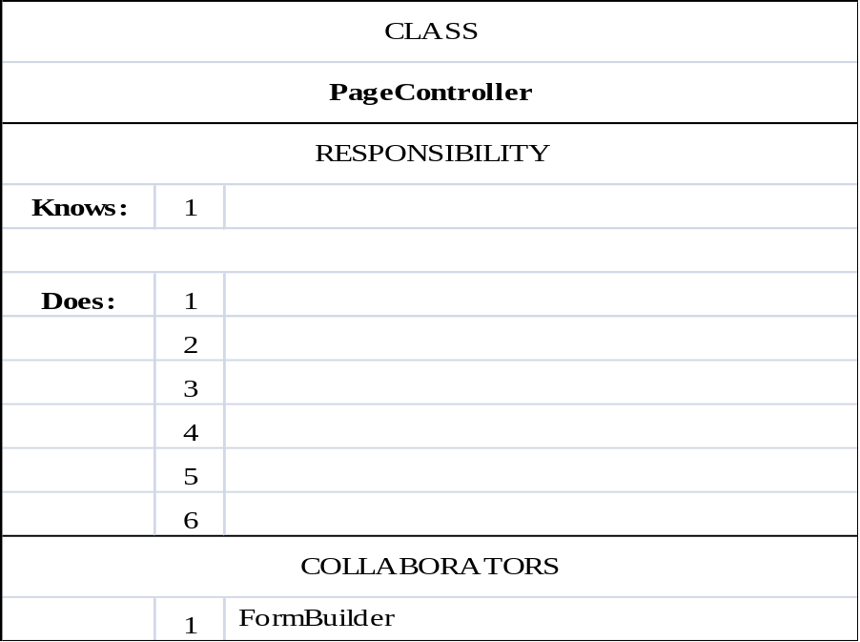
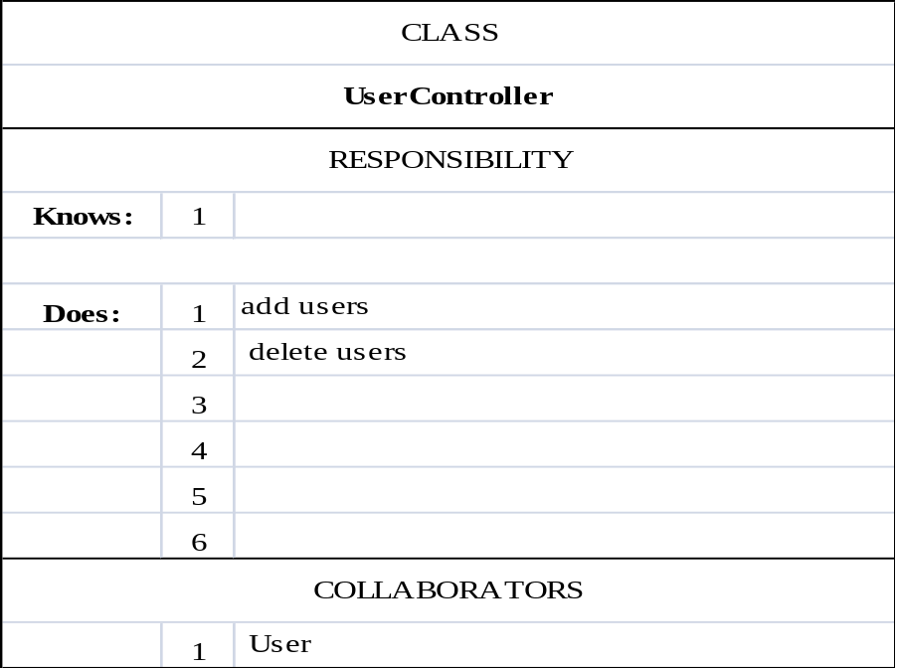
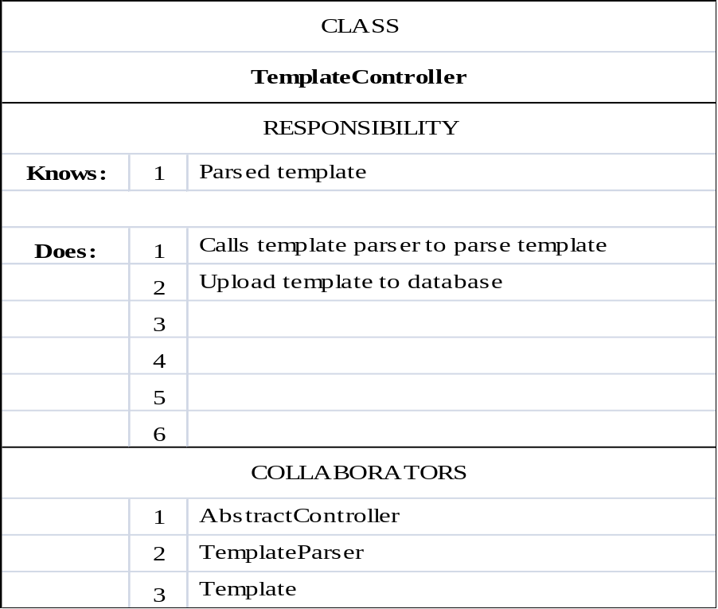
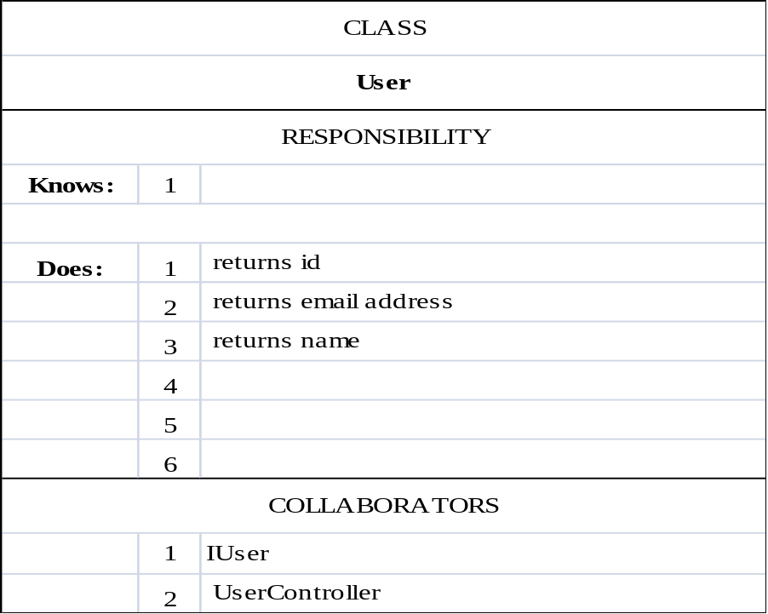
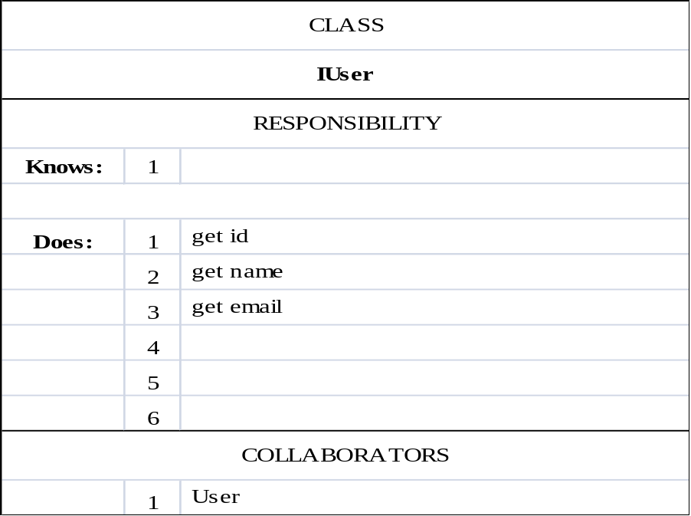
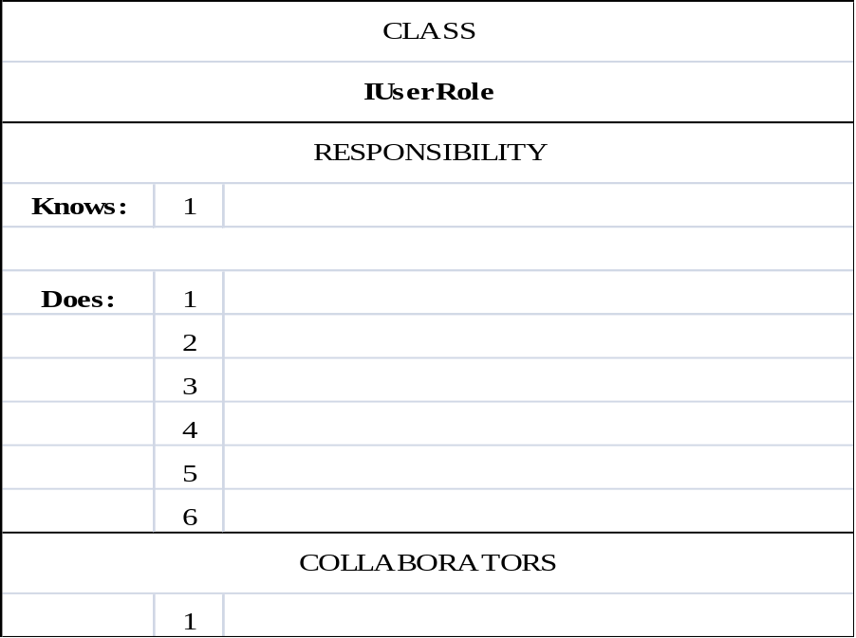
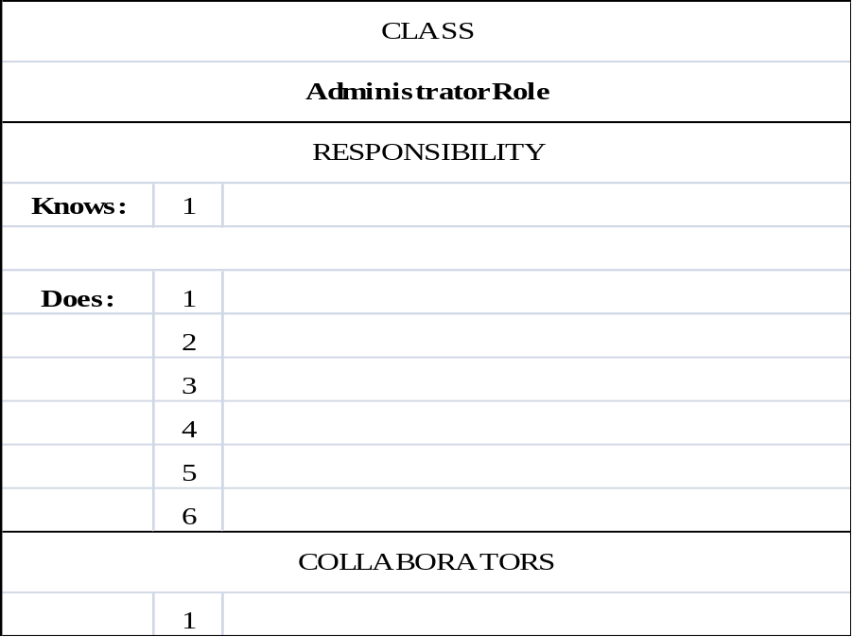
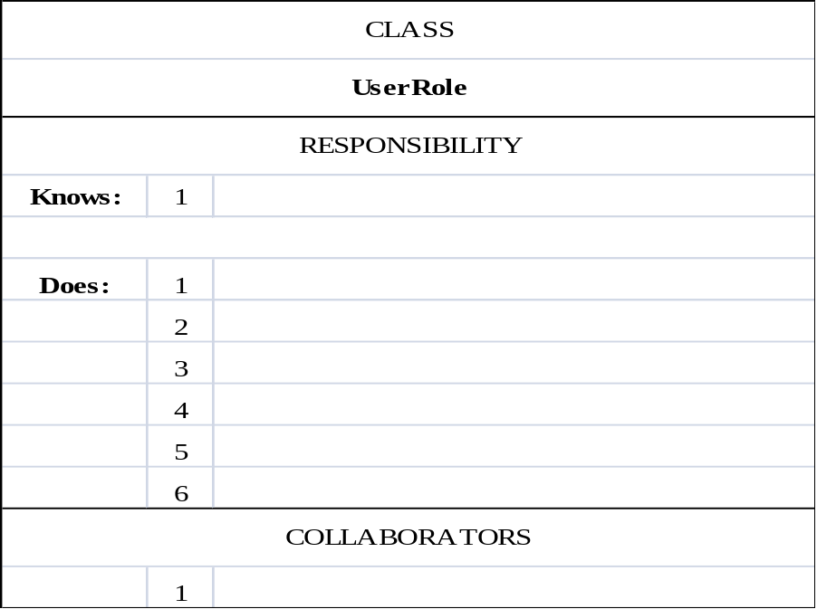
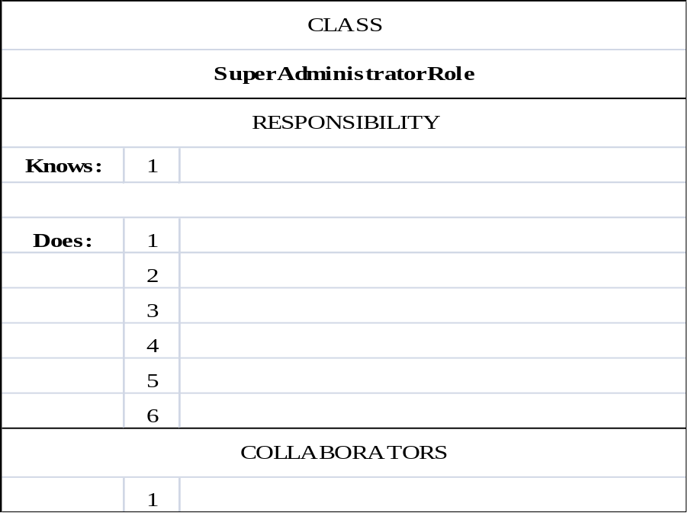
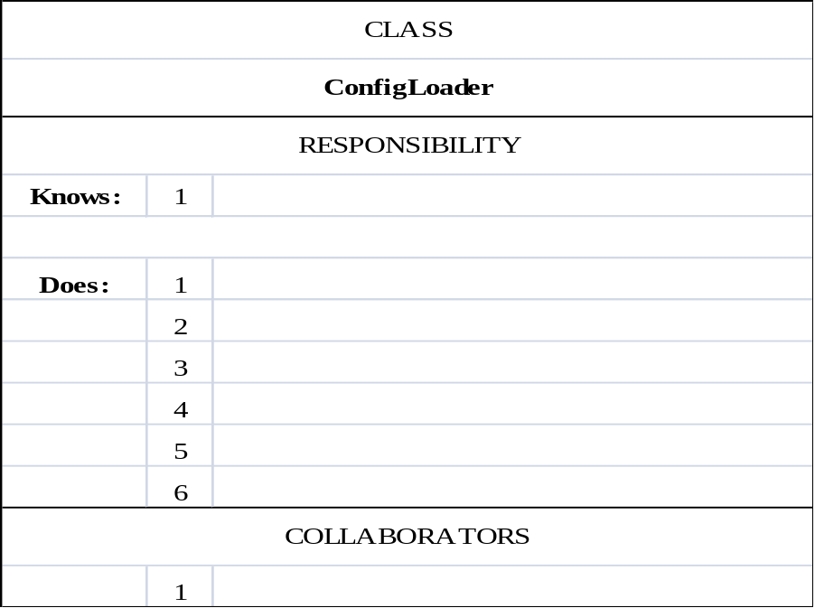
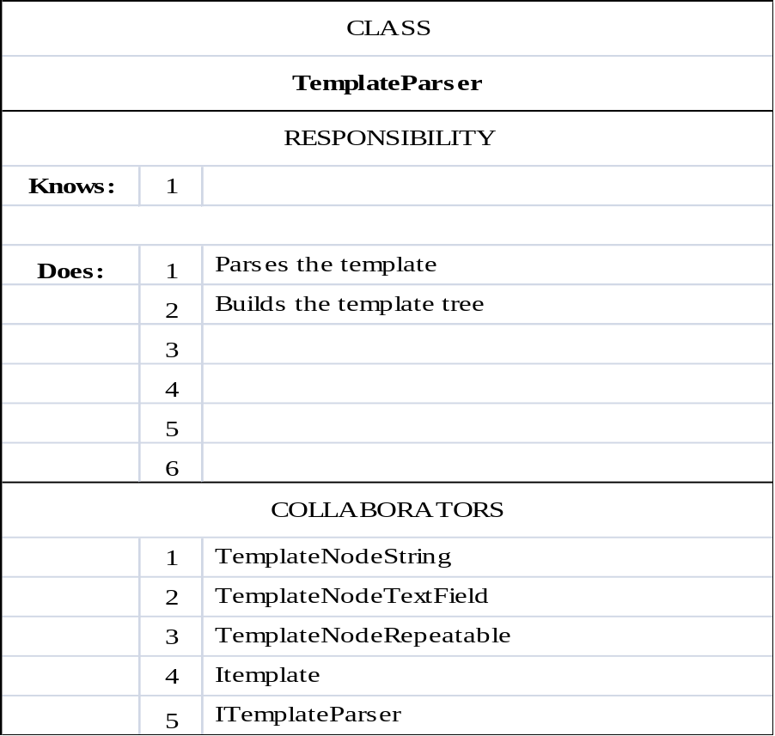
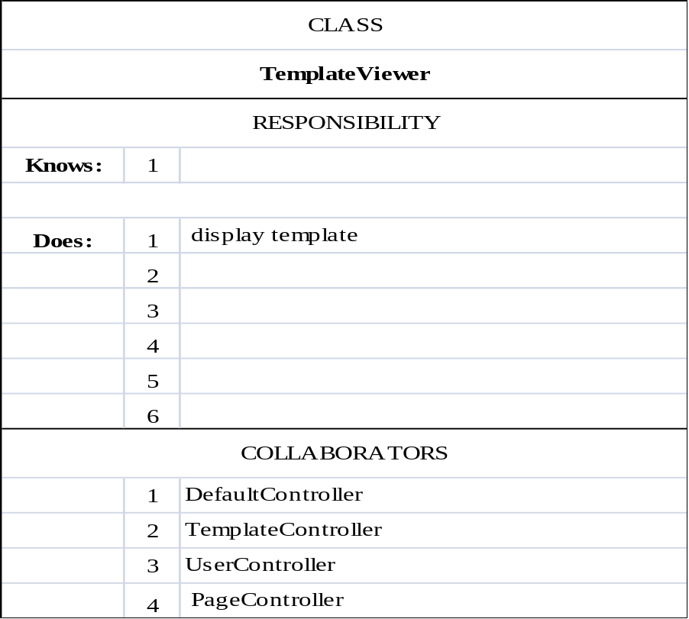
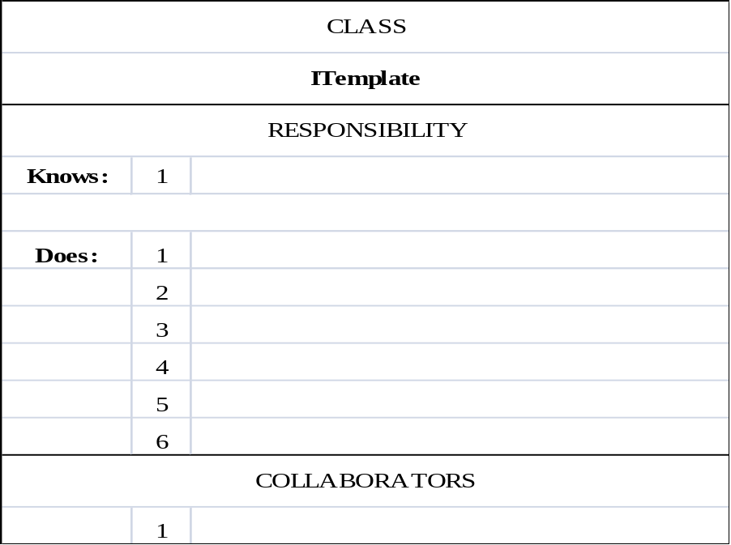
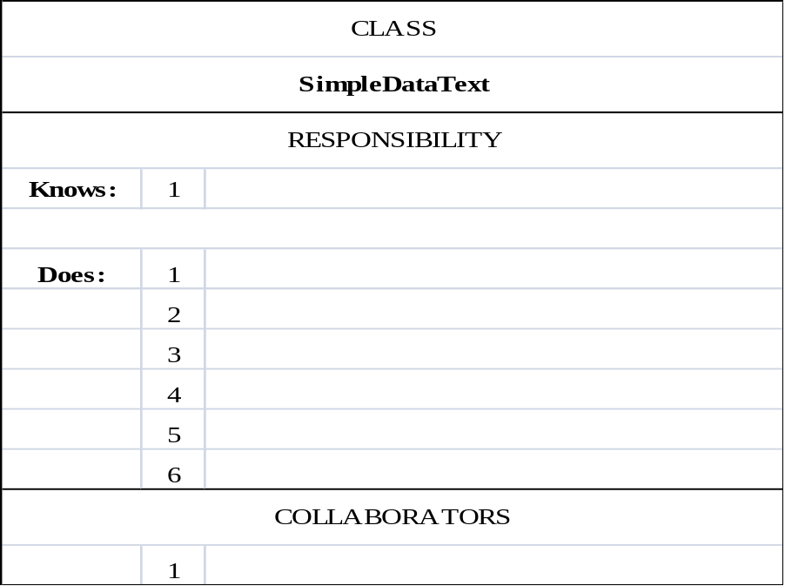
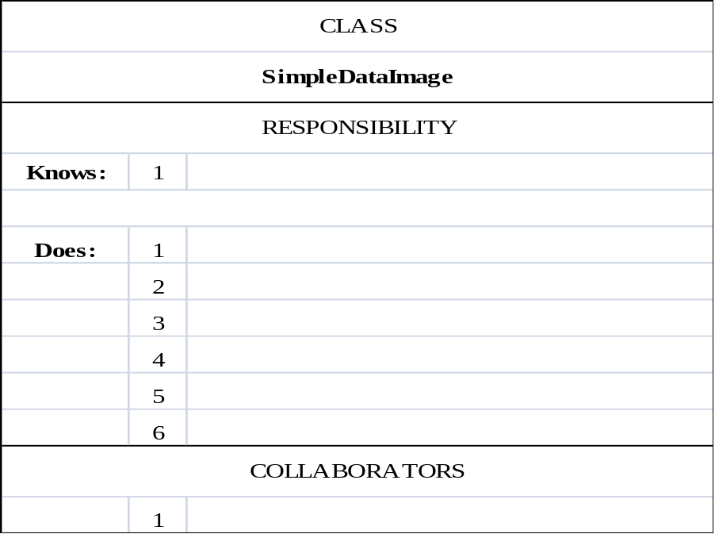
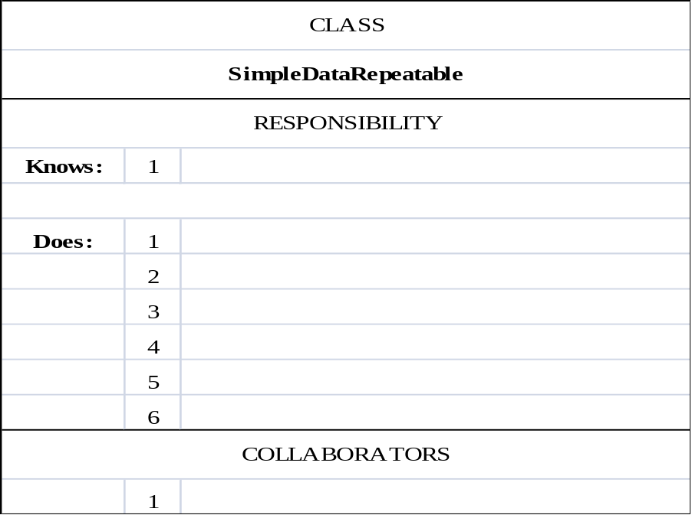
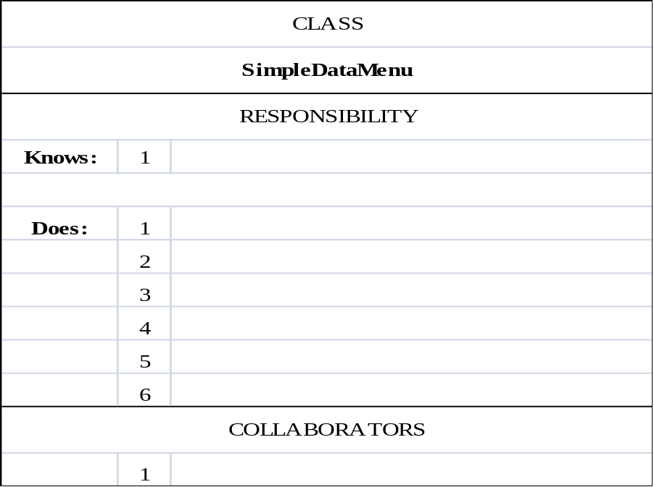
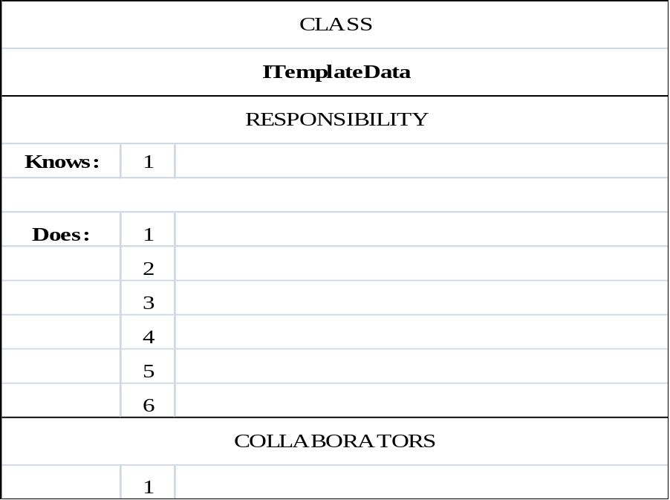
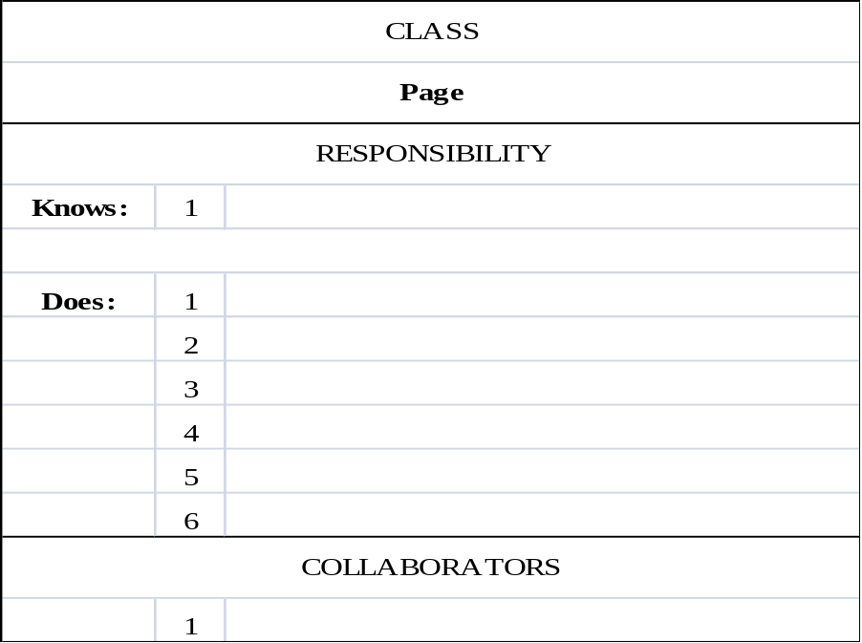
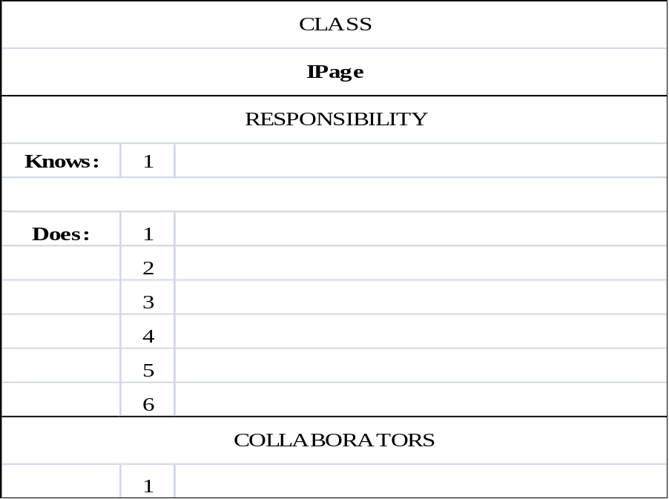
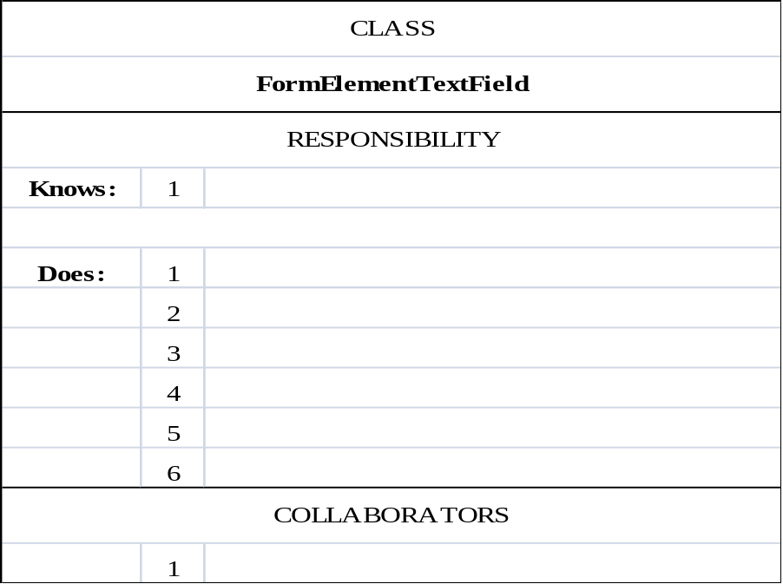
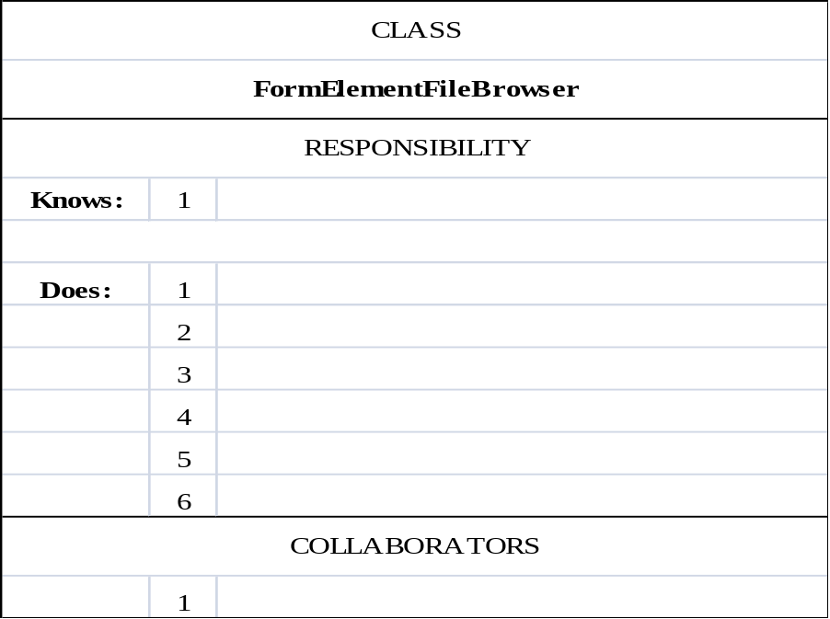
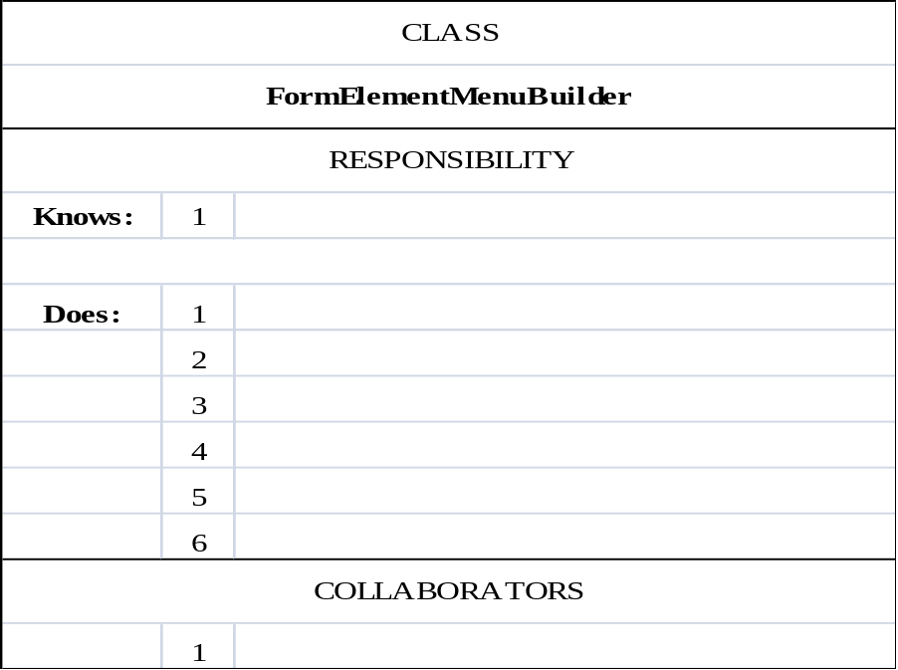
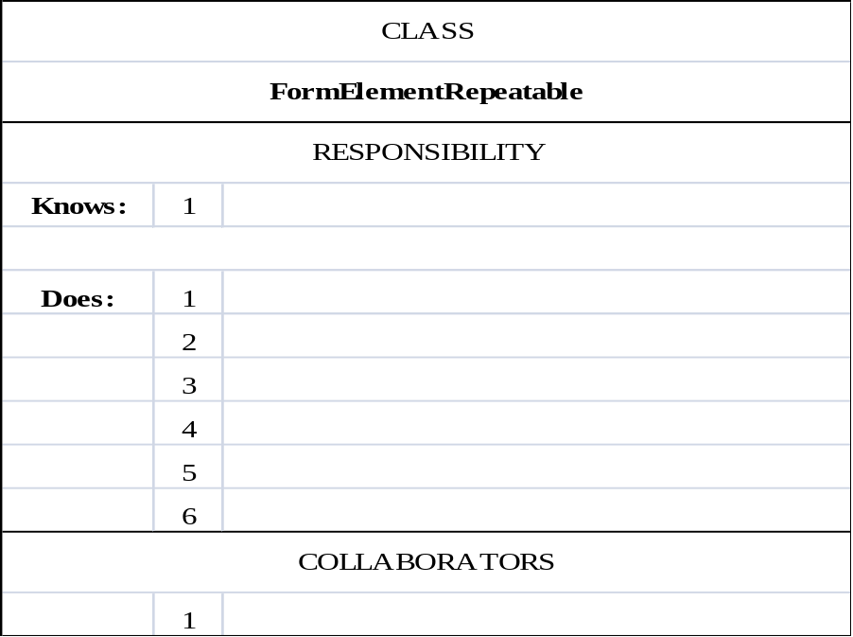
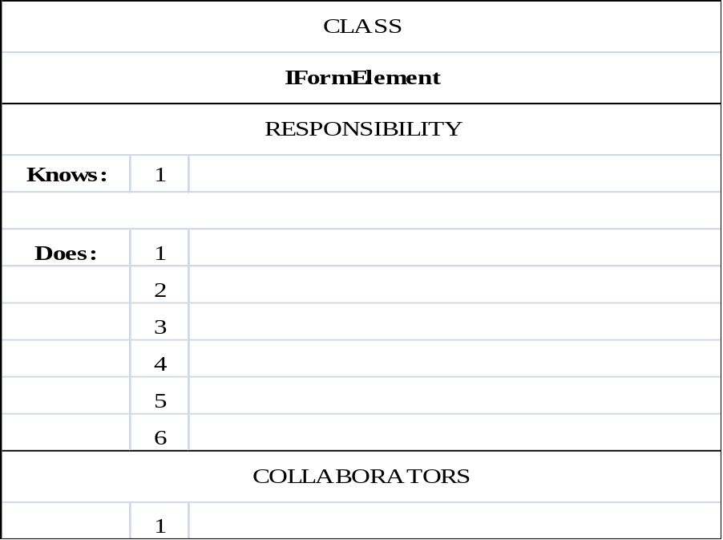

Class List:

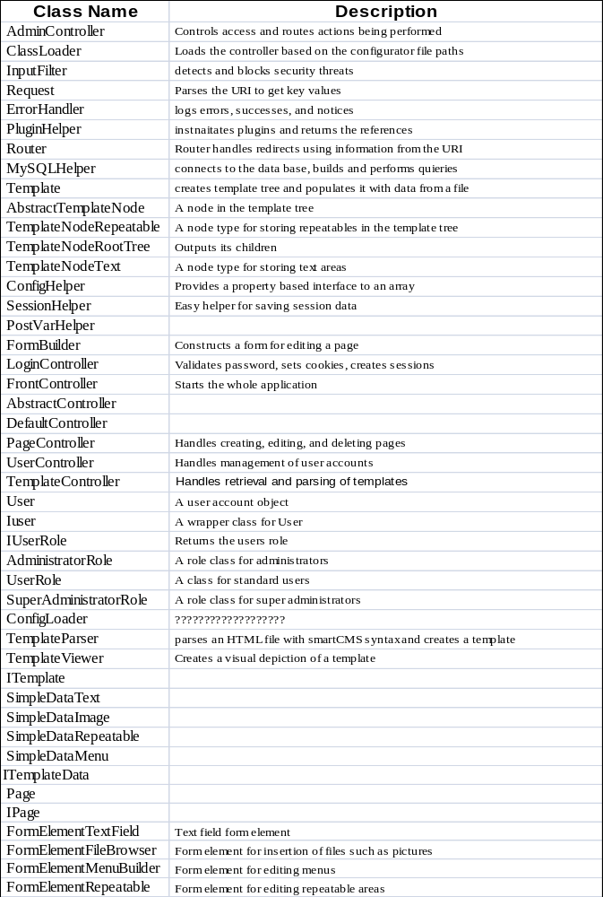

Sequence Diagram of Add a User:
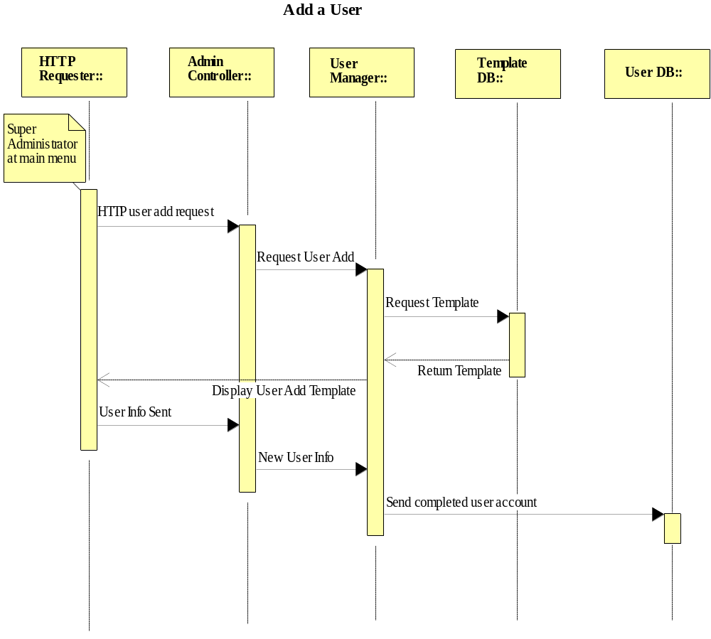
Sequence Diagram of Logging on with Correct Credentials:
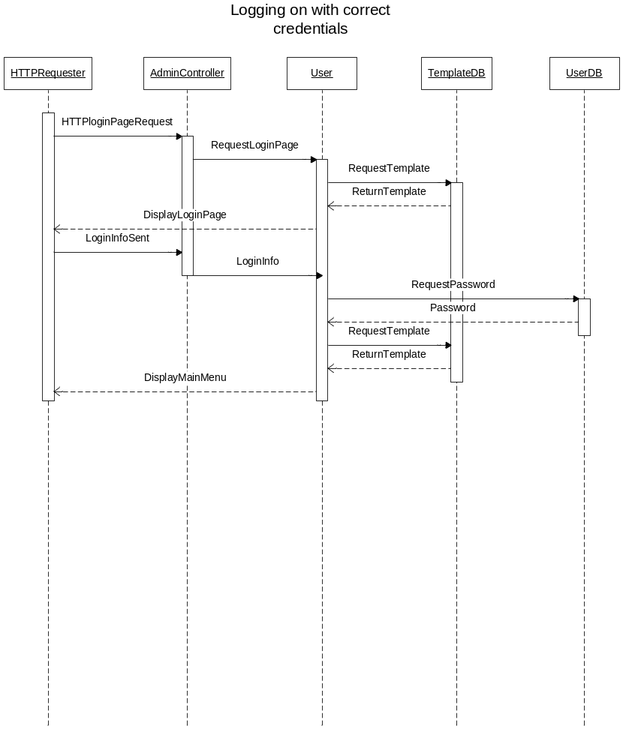
Sequence Diagram of Logging on with Incorrect Credentials:
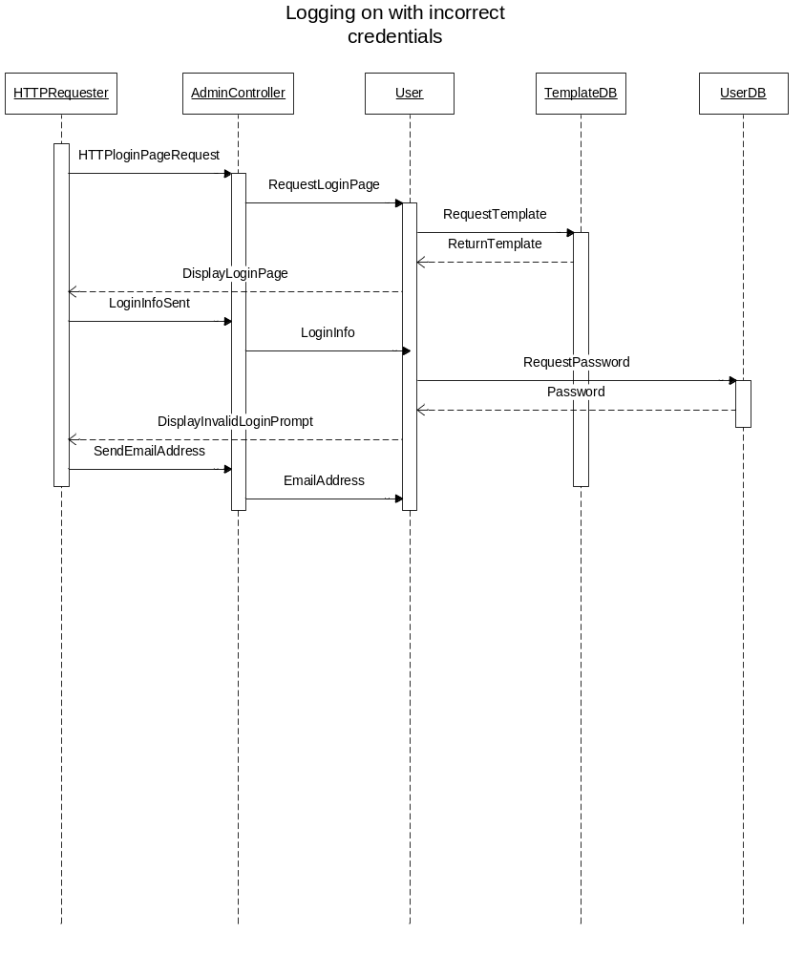
Sequence Diagram of Upload a new template with no errors:
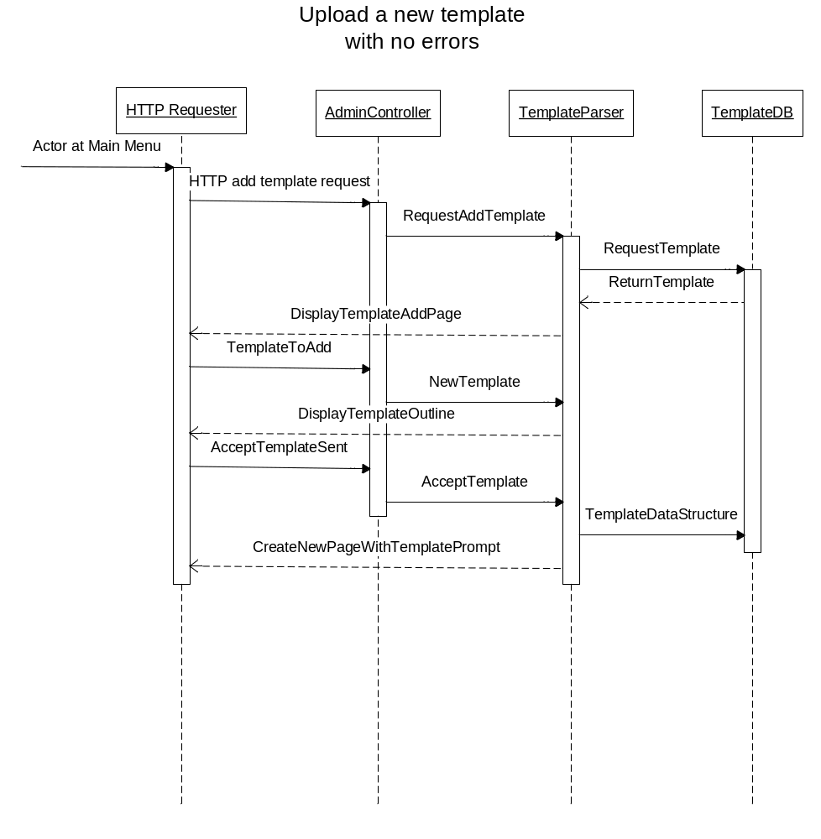
Sequence Diagram of Upload a New Template:
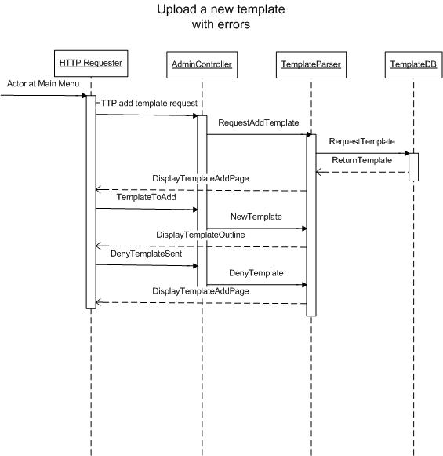
Sequence Diagram of Edit a Page:
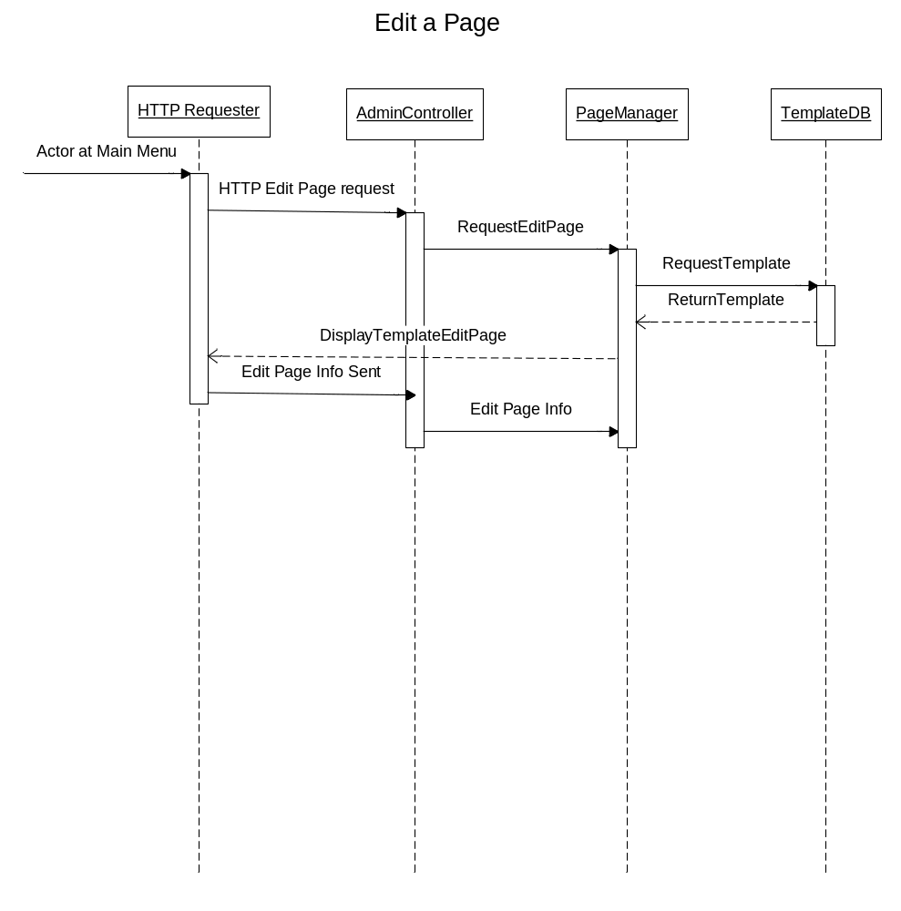
Sequence Diagram of Create a New Page:
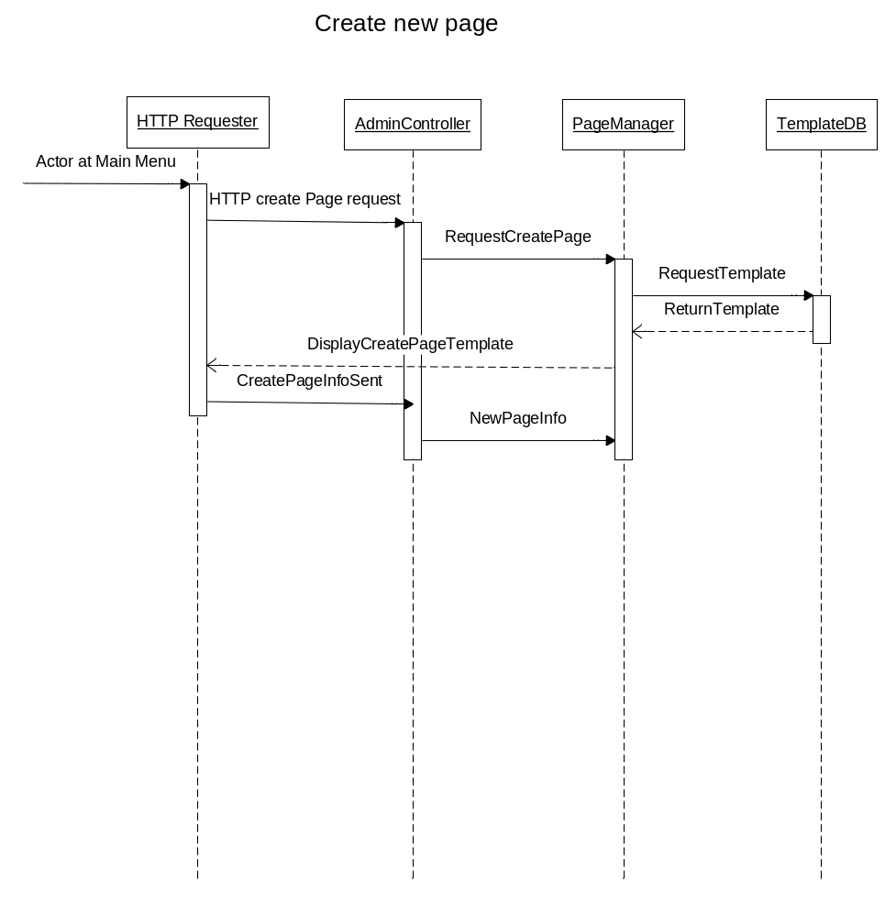

Class Diagram of Page Controller:
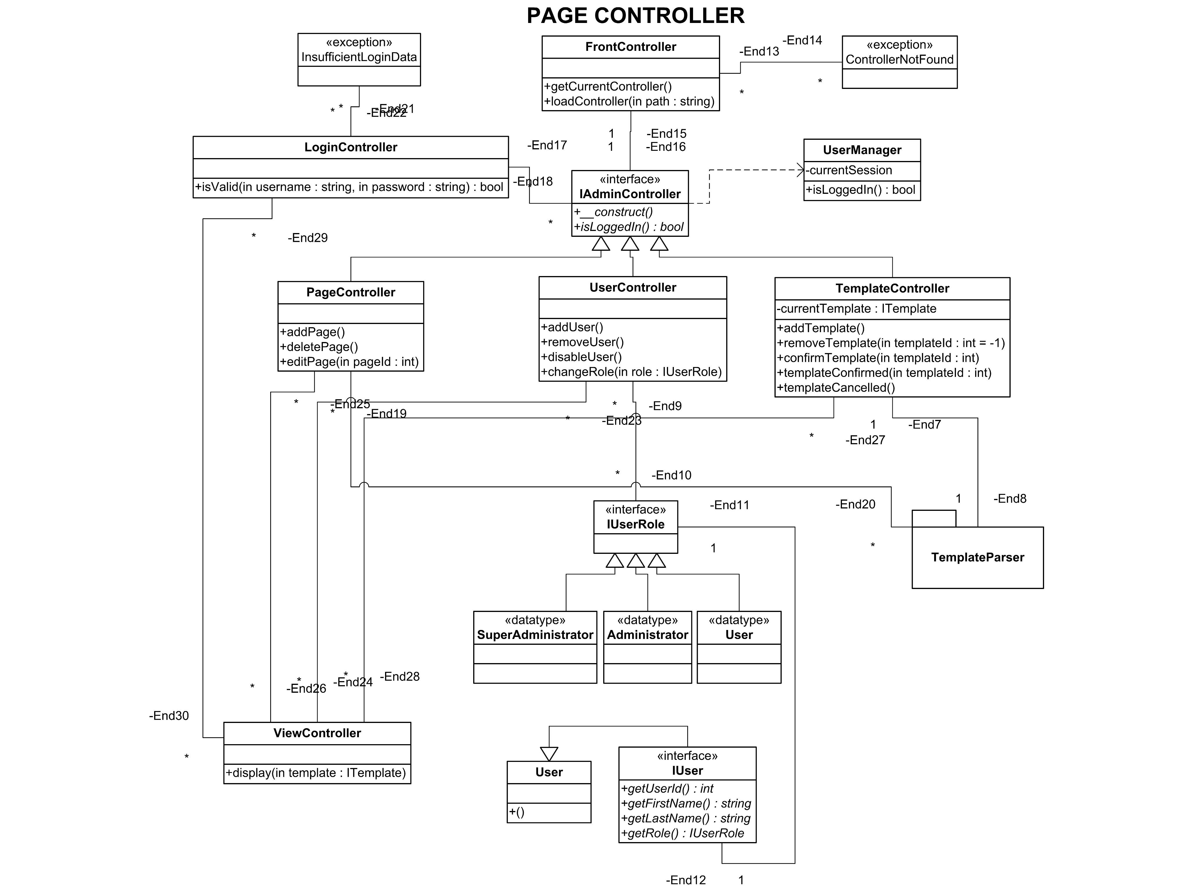
Class Diagram of Template Parser:
